AngleMog Lincolnshire Wings & Wheels Break

From 12/5 to 16/5 29 members of AngleMog toured the various historic RAF related sites in Lincolnshire.
Peter Tatlow did us proud as the tour organizer.
We stayed at the Petwood House Hotel which was the officers mess for 617 the Dambuster Squadron in the second world war. A very comfortable location ideally positioned with a pre-dinner lounge with bar & our own dining room. The rhododendrons in the extensive grounds were another attraction.
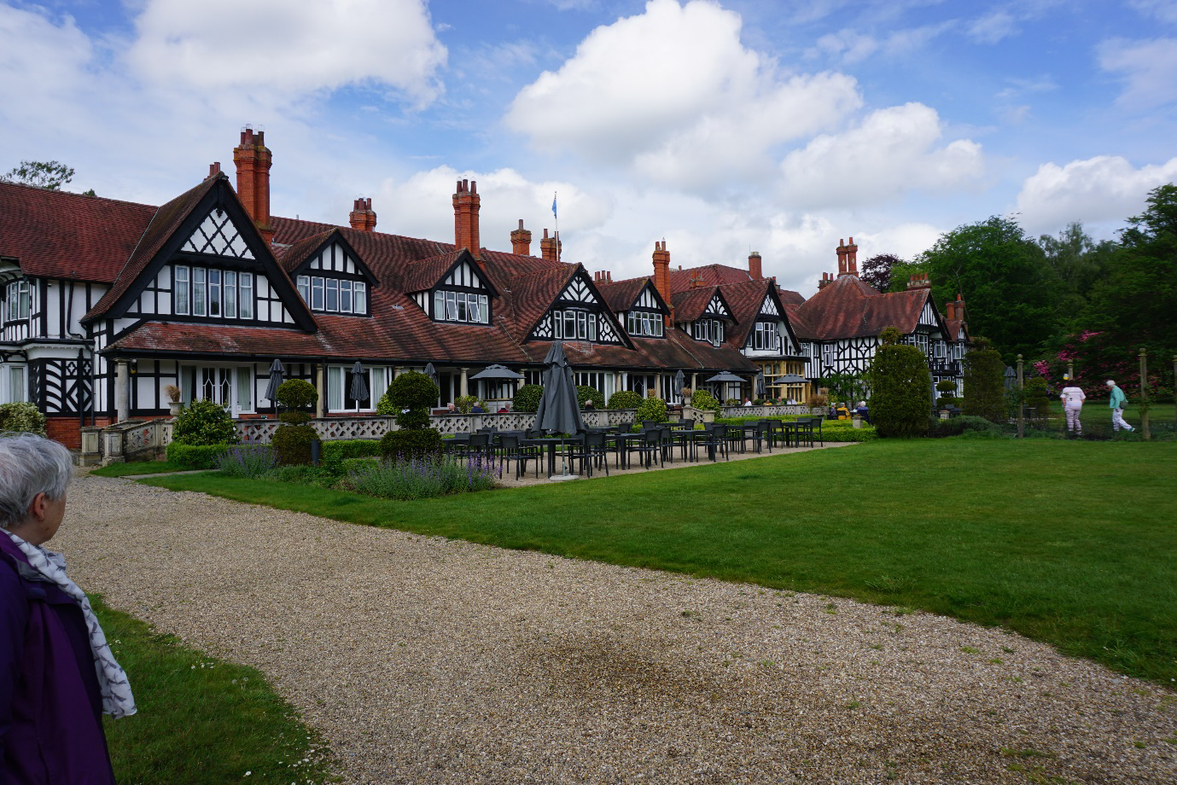
We started the first day with a guided tour of the Battle of Britain Memorial Flight based at RAF Coningsby, enjoying the sound of a Merlin engine battling the roar of Typhoons. The static display inside the hanger included a Hurricane, Spitfires & the Lancaster, City of Lincoln
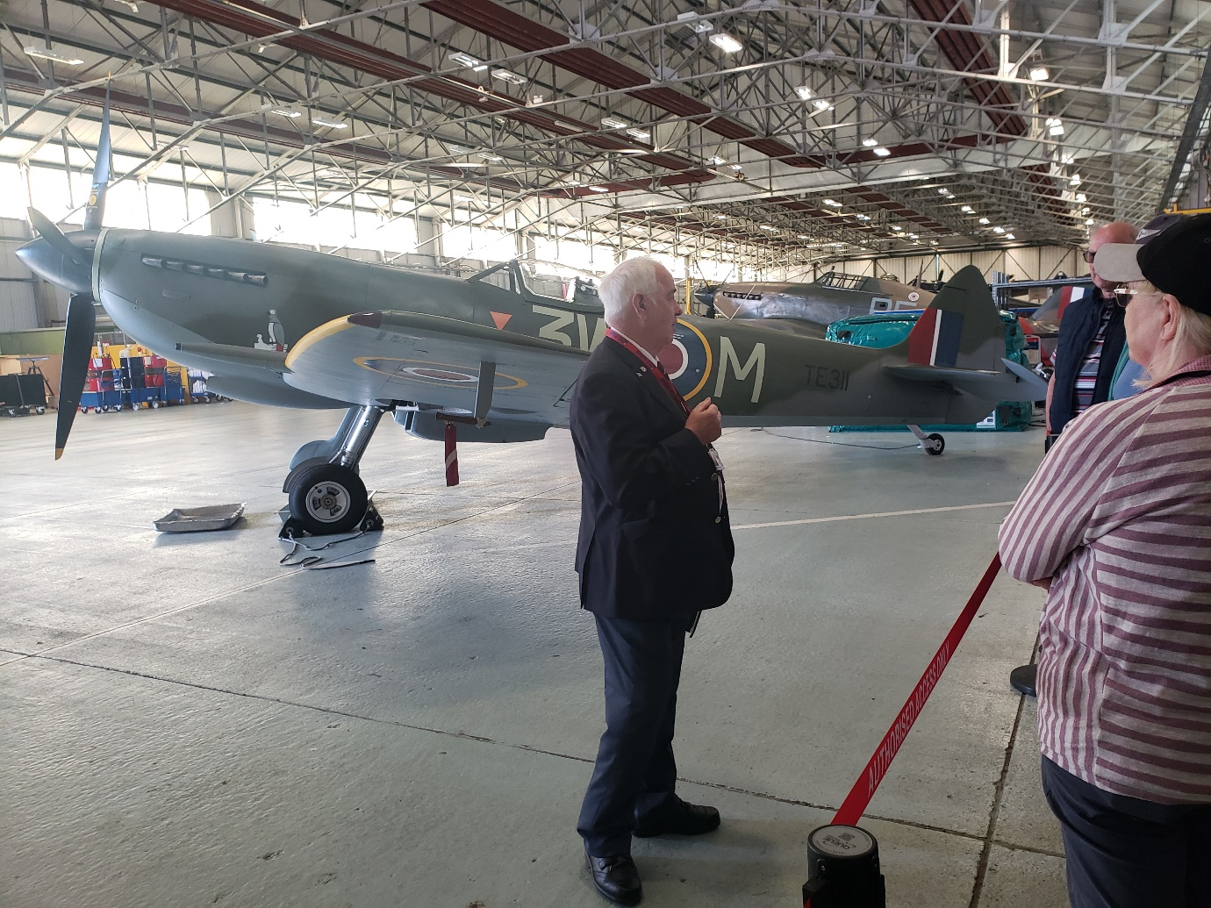
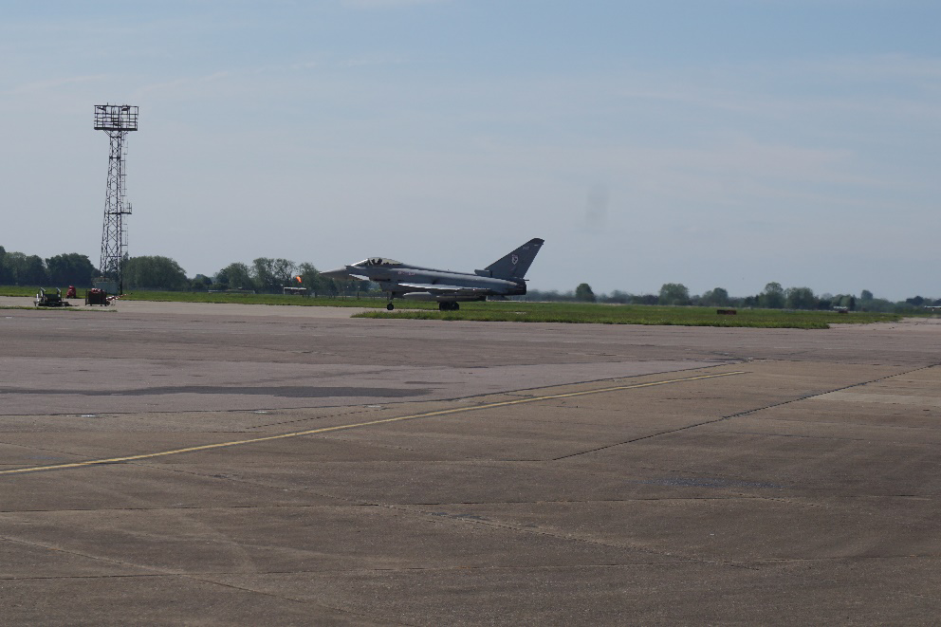
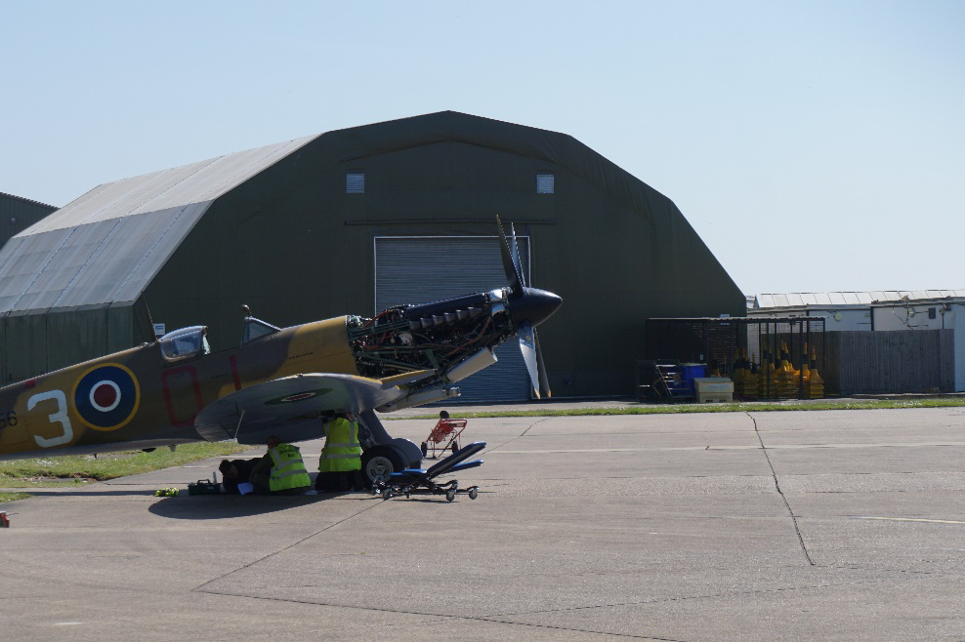
In the afternoon we had a private tour of the Operations Room from WWII at RAF Digby, still an active operational base. The Operations Room itself was closed & left at VE Day and is an amazing time capsule.

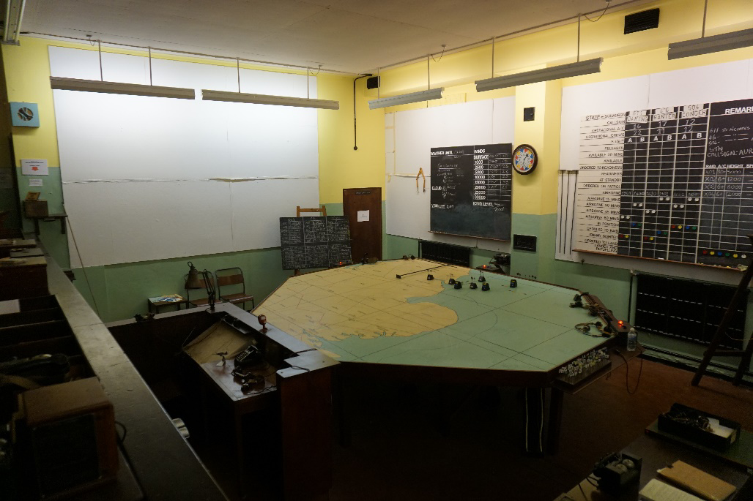
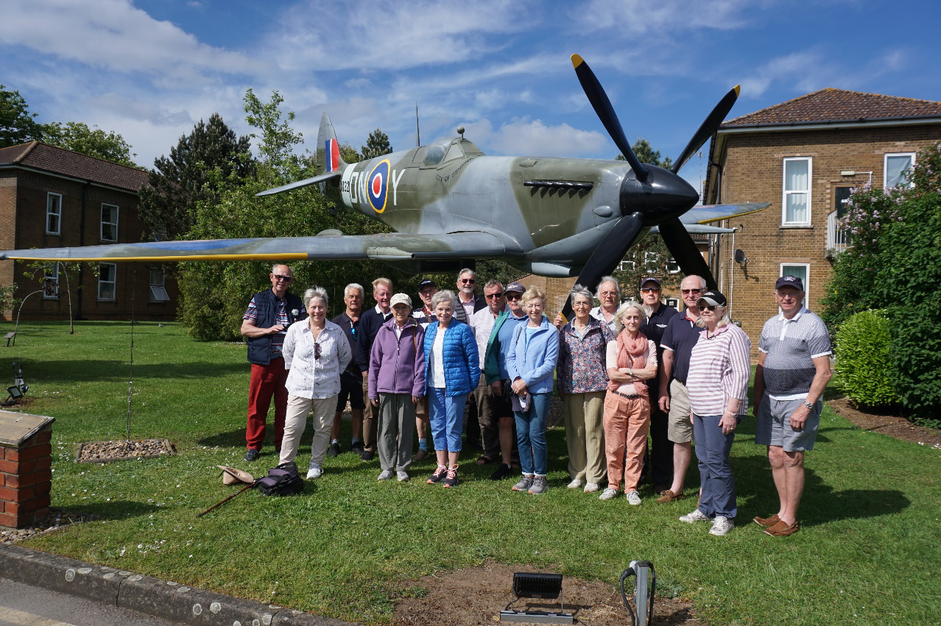
After dinner Mr Geoff Tipler provided a detailed lecture on the Lancaster which really reinforced how brave the young people who flew them were.
The next day we headed off to the Lincolnshire Aviation Heritage Centre at East Kirkby to see their Lancaster bomber Just Jane taxi. Peter had organised that we parked by the runway and were treated to the spectacle of four Merlins starting up, the prop wash and the sight of the plane in action.
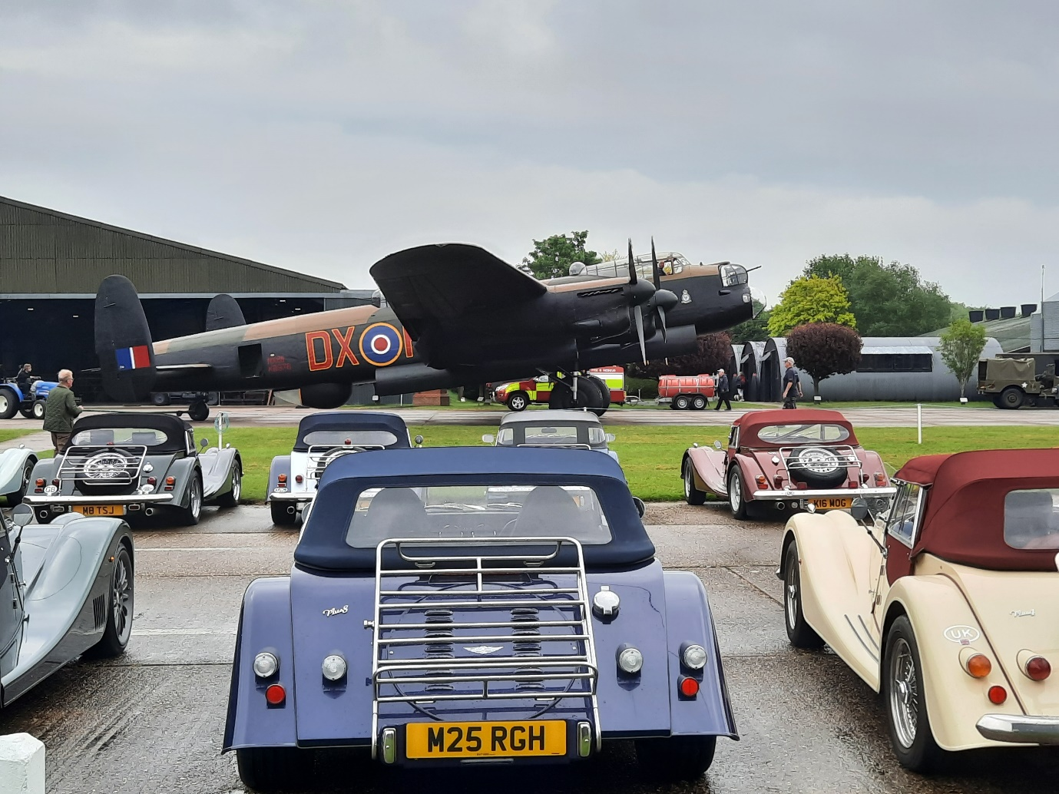
We then had a guide take us around the outside of the plane before getting to park our cars infront of the Lancaster for a photo.
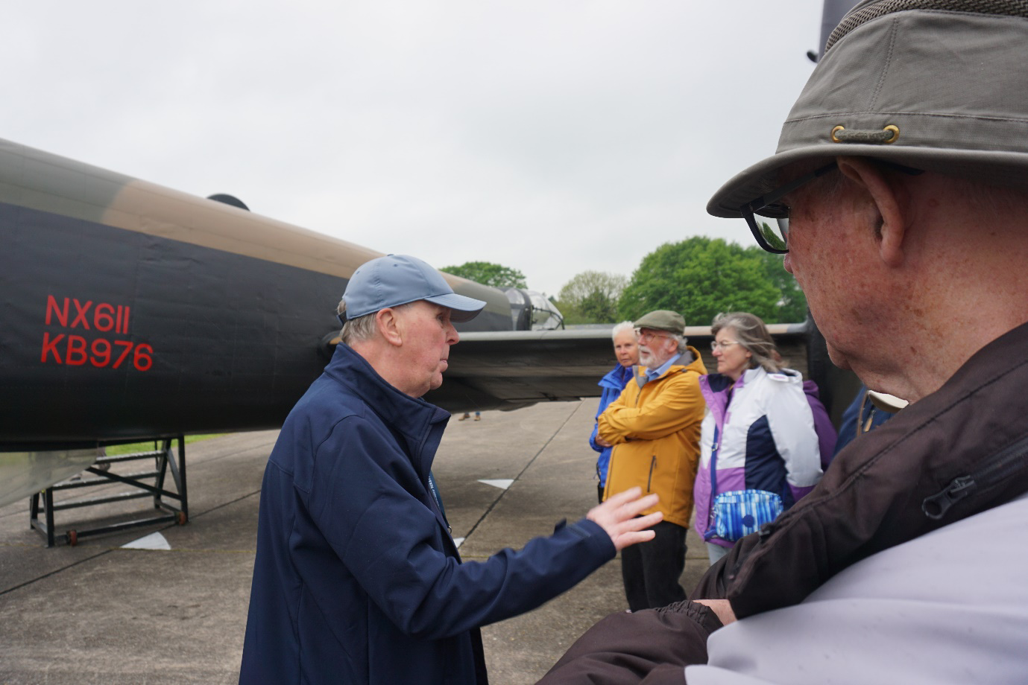
This wasn’t a first for AngleMog having done it before in 2011.

2011
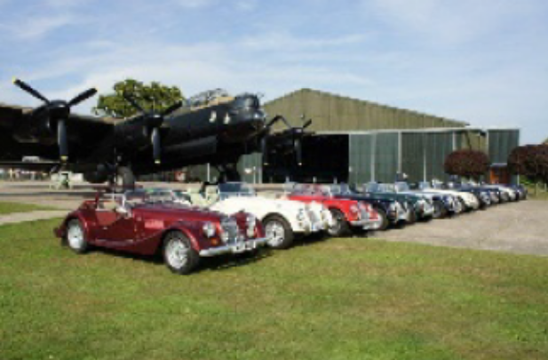
2024
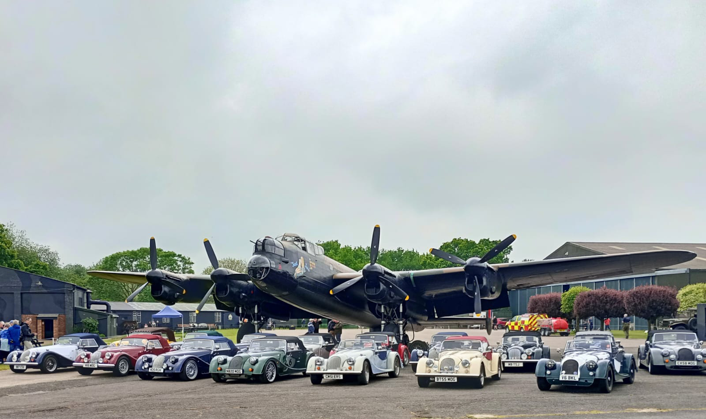
Oxmog also were at the museum that day so I met again many friends from when I lived in Bucks.

We finished off with a tour of the International Bomber Command Centre near Lincoln which is a touching memorial to all who died in bomber command in WWII. The Mogs were allowed to park in front of the sculpture Op Manna, depicting the allies food drop over the Netherlands at the end of Wll.
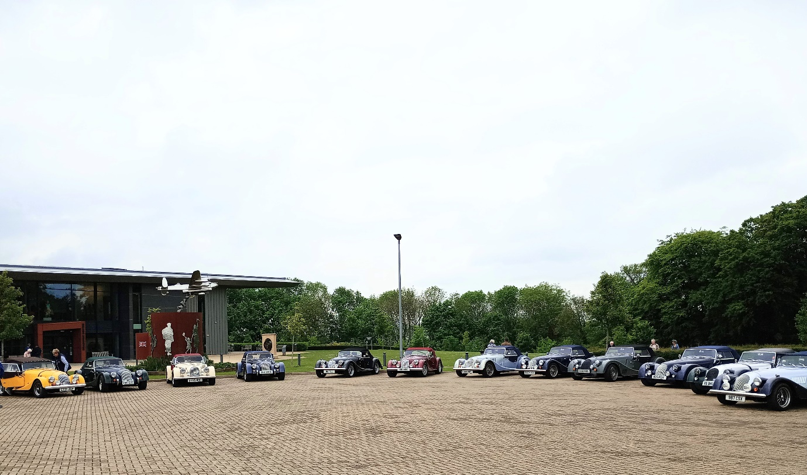

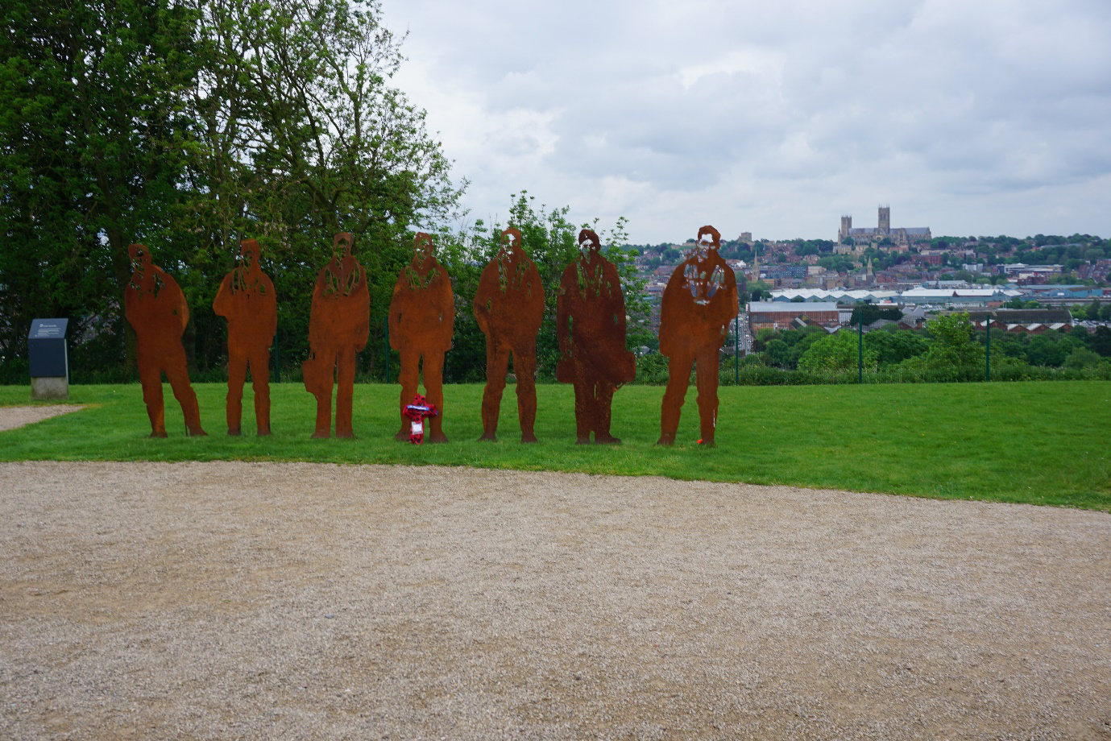
Thanks again Peter & Beryl for all your hard work to make our holiday a success.

